ROCK, PAPER, SCISSOR -
PHILIPPINE HISTORY EDITION

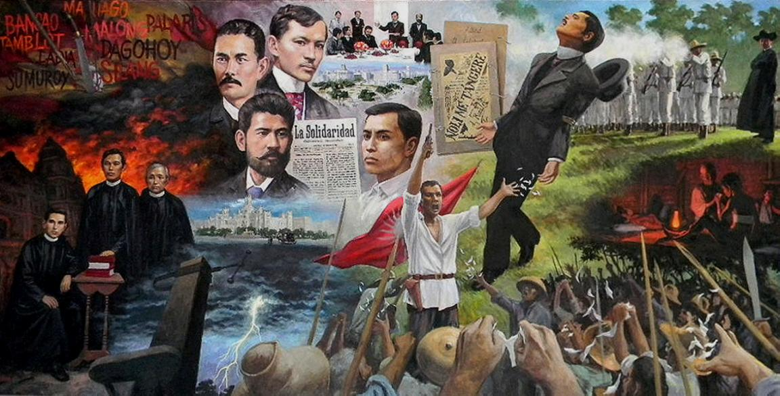

Objective of the game:
To play the fun and traditional rock paper scissor by two players with a twist - adding questions about the history of the Philippines.

Mechanics of the game:
- Before the game starts, the player will be ask to choose level of difficulty:
- Easy
- Medium
- Hard
Each level will determine the kind of history questions the user need to answer in order to attain points.

- After choosing game difficulty, the player will now enter the players’ names. The game will require two players to start the game.

- The game will begin with the traditional rock, paper, scissor game but the twist is if you won the round, you will get the chance to answer the given history question after it which will give you points to win.
- If you fail to answer the question, you won’t get points and the chance will be given to the other player to answer the history question.
- Whoever gets the correct answer will win otherwise if no one gets the correct answer, no one will get the points.

- The game will continue up to 10 rounds with different history questions and players can only attain points if they answered the history questions correctly.

- After 10 rounds of playing, the game will display the winner as well as the history of the game . History of the game will consist of the questions, players’ answers and the correct answer.

- After displaying the winner and the game history, player will be asked if he/she wants to redeem the points and choose from the available prizes.

- The game will continue if the player wants to play again or not.

MEMBERS:
ANTARAN, MG
CARAMAT, JOSH IVAN
DY, ANGELY MAE

